HEREDITY WORKSHEET

1.A green stemmed rose plant denoted by GG and a brown stemmed rose plant denoted by gg are allowed to undergo a cross with each other.
(a) List your observations regarding :
(i) Colour of stem in their F₁ progeny
(ii) Percentage of brown stemmed plants in F₂ progeny if plants are self pollinated.
(iii) Ratio of GG and Gg in the F₂ progeny.
(b) Based on the findings of this cross, what conclusion can be drawn?

2.What will be the result in F₁ generation when a homozygous white male rabbit is crossed with a homozygous black female rabbit?

3Reason : A heterozygous tal
l plant will produce two types of gametes, i.e., one with T and other with t whereas homozygous dwarf plant produce all gametes with t only..Assertion : A heterozygous tall plant when crossed with homozygous dwarf plant will produce tall and
dwarf plants in the ratio of 3:1.

4.Gregor Mendel conducted hybridisation experiments on garden peas for seven years and proposed the laws of inheritance in living organisms. He investigated characters in the garden pea plant that were manifested as two opposing traits, e.g., tall or dwarf plants, yellow and green seeds, etc.
(1) Among the seven pairs of contrasting traits in pea plant as studied by Mendel, the number of traits related
to flower, pod and seed respectively were
(a) 2,2,2 | (b) 2,2,1
(c) 1,2,2 | (d) 1,1,2.
(2) The colour based contrasting traits in seven contrasting pairs, studied by Mendel in pea plant were
(a) 1 | (b) 2
(c) 3 | (d) 4.
(3) Refer to the given table of contrasting traits in pea plants studied by Mendel.
Character | Dominant trait | Recessive trait
(i) Seed colour | 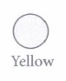
(ii) Flower colour | 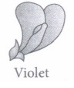 | 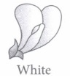
(iii) Pod shape | 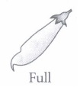 | 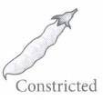
(iv) Flower position | 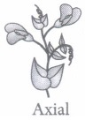 | 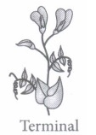

Which of the given traits is correctly placed?
(a) (i), (ii) and (iii) only
(b) (ii), (iii) and (iv) only
(c) (ii) and (iii) only
(d) (i), (ii), (iii) and (iv)
(4) Some of the dominant traits studied by Mendel were
(a) round seed shape, green seed colour and axial flower position
(b) terminal flower position, green pod colour and inflated pod shape
(c) violet flower colour, green pod colour and round seed shape
(d) wrinkled seed shape, yellow pod colour and axial flower position.
(5) Which of the following characters was not chosen by Mendel?
(a) Pod shape | (b) Pod colour
(c) Position of flower | (d) Position of pod

CASE STUDY

Mendel crossed tall and dwarf pea plants to study the inheritance of one gene. He collected the seeds produced as a result of this cross and grew them to generate plants of the first hybrid generation which is called the first filial progeny or F₁: Mendel then self pollinated the tall F₁ plants and he obtained F₂ generation.
(i) In garden pea, round shape of seeds is dominant over wrinkled shape. A pea plant heterozygous for round shape of seed is selfed and 1600 seeds produced during the cross are subsequently germinated. How many seedlings would have non-parental phenotype?
(a) 1600 | (b) 1200
(c) 400 | (d) 800
(ii) If 'A' represents the dominant gene and 'a' represents its recessive allele, which of the following would be the most likely result in the first generation offspring when Aa is crossed with aa ?
(a) All will exhibit dominant phenotype.
(b) All will exhibit recessive phenotype.
(c) Dominant and recessive phenotypes will be 50% each.
(d) Dominant phenotype will be 75%.
(iii) Which of the following crosses will give tall and dwarf pea plants in same proportions?
A) 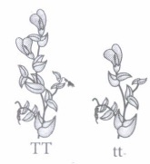 | B)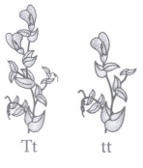
c) 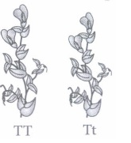 | D) 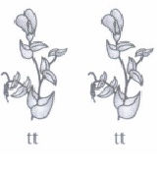

(iv) What result Mendel would have got, if he self pollinated a homozygous tall F₂ plant?
(a) TT and Tt
(b) All Tt
(c) All TT
(d) All tt
(v) In plant, tall phenotype is dominant over dwarf phenotype, and the alleles are designated as T and t, respectively. Upon crossing one tall and one dwarf plant, total 250 plants were obtained, out of which 124 displayed tall phenotype and rest were dwarf. Thus, the genotype of the parent plants were
(a) TT x TT
(b) TT x tt
(c) Tt x Tt
d) Tt x tt.

